CODDENHAM

HOUSING & POPULATION DATA PROFILE
[Parish level]

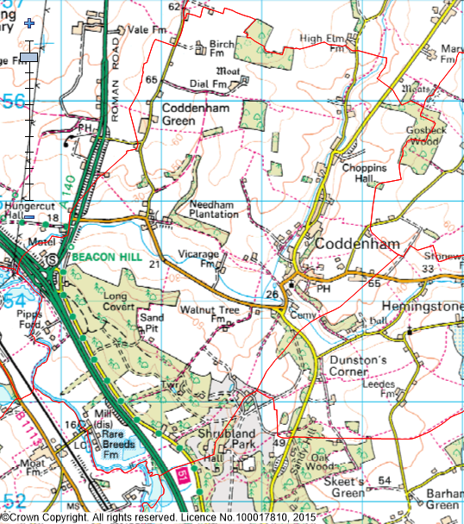
(Last Updated: October 2019)

This Parish Profile has been produced primarily to help inform local discussion on housing need.
Most of the data comes from the 2011 Census (accessible via the ONS website). Other data sources have also been used as appropriate, and will be updated periodically.

How many people live locally? | Children Under  16 | Working  Age Adults  (16 to 64) | People  Aged  65 + | Dependency Ratio
620 | 127 (20.5%) | 394 (63.5%) | 99 (16.0%) | 0.57
49.8% Males  50.2% Females | Mid Sflk Avg = 18.4%  England Avg = 18.9% | Mid Sflk Avg = 61.5%  England Avg = 64.7% | Mid Sflk Avg = 20.1%  England Avg = 16.3% | Mid Sflk Avg = 0.63  England Avg = 0.55

[Source: ONS 2011 Census: KS101EW & KS102EW] [Dependency Ratio = Ratio of Non-working Age to Working Age Population]

Single Pensioner Households | Single H/holds  < 65 years old | Lone Parent Families  with Dependent Children
24 | 32 | 15
9.4% of all Households  Mid Suffolk Avg = 12.9%  England Avg = 12.4% | 12.5% of all Households  Mid Suffolk Avg = 12.4%  England Avg = 17.9% | 19.5% of all families with dependent children  Mid Suffolk Avg = 17.7%  England avg = 24.5%

[Source: ONS 2011 Census: KS105EW]

General Health (All Usual Residents)

Very Good  49.2% | Good  35.3% | Fair  12.9% | Bad  1.6% | Very Bad  1.0%
Mid Sflk Avg = 47.9%  England Avg = 47.2% | Mid Sflk Avg = 35.3%  England Avg = 35.2% | Mid Sflk Avg = 12.8%  England Avg = 12.8% | Mid Sflk Avg = 3.1%  England Avg = 3.6% | Mid Sflk Avg = 0.8%  England Avg = 1.0%

[Source: ONS 2011 Census: QS302EW]

Total # Occupied  Households | Owned (Outright or with Mortgage) | Shared Ownership | Socially  Rented | Privately  Rented
256 | 180 (70.3%) | 1 (0.4%) | 29 (11.3%) | 39 (15.2%)
 | Mid Sflk Avg = 75.1%  England Avg = 63.3% | Mid Sflk Avg = 0.8%  England Avg = 0.8% | Mid Sflk Avg = 11.3%  England Avg = 17.7% | Mid Sflk Avg = 11.2%  England Avg = 16.8%

[Source: ONS 2011 Census: QS405EW]
- At the time of the 2011 Census some 13 dwellings (4.8% of all dwellings in Coddenham) appeared to be unoccupied. (Mid Suffolk Avg = 3.8%) [QS418EW]
Number of Bedrooms (Occupied Households)

None | 1 bed | 2 bed | 3 bed | 4 bed +
0 (0%) | 12 (4.7%) | 61 (23.8%) | 84 (32.8%) | 99 (38.7%)
Mid Sflk Avg = 0.1%  England Avg = 0.2% | Mid Sflk Avg = 6.0%  England Avg = 11.8% | Mid Sflk Avg = 25.0%  England Avg = 27.9% | Mid Sflk Avg = 40.4%  England Avg = 41.2% | Mid Sflk Avg = 28.5%  England Avg = 18.9%

[Source: ONS 2011 Census: QS411EW]

Total # Occupied  Households | Total # with Under-Occupied bedrooms | Total # with Over-Occupied bedrooms
256 | 215 (83.9%) | 6 (2.3%)
 | Mid Sflk Avg = 80.8% / England Avg = 68.7% | Mid Sflk Avg = 1.6% / England Avg = 4.6%

[Source: ONS 2011 Census: QS412EW]

NET NEW RESIDENTIAL COMPLETIONS (Last 5 Years: April to March)
2013/14 | 2014/15 | 2015/16 | 2016/17 | 2017/18
0 | 16 | 1 | 1 | 0

[Source: Babergh & Mid Suffolk Joint Annual Monitoring Report]

Avg Price & No (in brackets) of Properties Sold in IP6 Postcode (Aug 2018)
Detached | Semi-Det’ | Terraced | Flat | All
£350,555 (9) | £242,699 (10) | £211,998 (10) | £0 (0) | £265.585 (29)

[Source: Right Move website: Market Trends]

Note: The average sold house price in Coddenham village is higher than the figure quoted above. According to Right Move, the overall average price for a house sold in Coddenham over the last twelve months was £199,417 (Data accessed 6 July 2015)

MID SUFFOLK
In Mid Suffolk, in 2017 …the average wage was £25,070. The average house price was £255,000. Therefore, the wage to house price ratio = x 10.17
[Source: ONS website: Median wages, median house prices and ratio calculation]

Other Information

- County Councillor = Cllr Matthew Hicks (Thredling Division)

- District Councillor = Cllr Tim Passmore and Cllr John Whitehead (Claydon and Barham Ward)

- Coddenham is identified as a Secondary Village in Policy CS1 of the Mid Suffolk Core Strategy DPD (Adopted Sept 2008)

- Local Services in Coddenham include … a local Convenience Store / Post Office, Village Hall and place of Worship

- 63% of all households in Coddenham with at least one usual resident are reliant on oil-fired heating [QS415EW]

- The following Housing Association’s (Registered Providers) are known to be active in Coddenham: Hastoe Housing and The Day Foundation

- The 2014 Suffolk Housing Survey shows that, across Mid Suffolk district:

  - 12% of all existing households contain someone looking for their own property over the next 3 years (mainly single adults without children). The types of properties they are interested in are flats / apartments, and smaller terraced or semi-detached houses. Although this is not their first preference, many accept that the private rented sector is their most realistic option.

  - 25% of households think their current property will not be suitable for their needs in 10 years’ time.

  - 2 & 3 bed properties are most sought after by existing households wishing to move.

  - Suitable housing options for more elderly people are less available within the current housing stock. 6% of all households have elderly relatives who may need to move to Suffolk within the next 3 years.

