HOXNE

HOUSING & POPULATION DATA PROFILE
[Parish level]

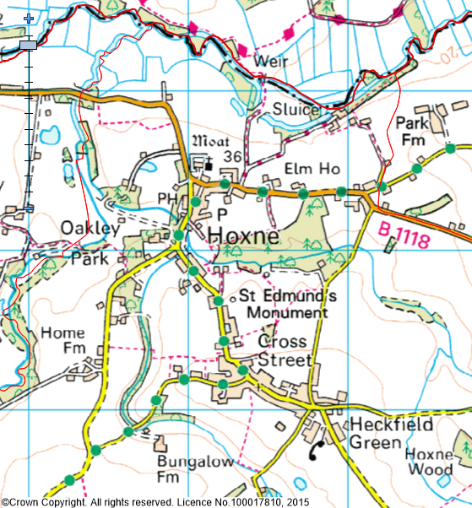
(Last Updated: October 2019)

This Parish Profile has been produced primarily to help inform local discussion on housing need.
Most of the data comes from the 2011 Census (accessible via the ONS website). Other data sources have also been used as appropriate, and will be updated periodically.

How many people live locally? | Children Under  16 | Working  Age Adults  (16 to 64) | People  Aged  65 + | Dependency Ratio
889 | 150 (16.9%) | 501 (56.3%) | 238 (26.8%) | 0.77
49.2% Males  50.8% Females | Mid Sflk Avg = 18.4%  England Avg = 18.9% | Mid Sflk Avg = 61.5%  England Avg = 64.7% | Mid Sflk Avg = 20.1%  England Avg = 16.3% | Mid Sflk Avg = 0.63  England Avg = 0.55

[Source: ONS 2011 Census: KS101EW & KS102EW] [Dependency Ratio = Ratio of Non-working Age to Working Age Population]

Single Pensioner Households | Single H/holds  < 65 years old | Lone Parent Families  with Dependent Children
61 | 47 | 22
15.9% of all Households  Mid Suffolk Avg = 12.9%  England Avg = 12.4% | 12.2% of all Households  Mid Suffolk Avg = 12.4%  England Avg = 17.9% | 22.4% of all families with dependent children  Mid Suffolk Avg = 17.7%  England avg = 24.5%

[Source: ONS 2011 Census: KS105EW]

General Health (All Usual Residents)

Very Good  46.6% | Good  31.9% | Fair  15.2% | Bad  4.8% | Very Bad  1.5%
Mid Sflk Avg = 47.9%  England Avg = 47.2% | Mid Sflk Avg = 35.3%  England Avg = 35.2% | Mid Sflk Avg = 12.8%  England Avg = 12.8% | Mid Sflk Avg = 3.1%  England Avg = 3.6% | Mid Sflk Avg = 0.8%  England Avg = 1.0%

[Source: ONS 2011 Census: QS302EW]

Total # Occupied  Households | Owned (Outright or with Mortgage) | Shared Ownership | Socially  Rented | Privately  Rented
384 | 248 (64.6%) | 4 (1.0%) | 72 (18.7%) | 53 (13.8%)
 | Mid Sflk Avg = 75.1%  England Avg = 63.3% | Mid Sflk Avg = 0.8%  England Avg = 0.8% | Mid Sflk Avg = 11.3%  England Avg = 17.7% | Mid Sflk Avg = 11.2%  England Avg = 16.8%

[Source: ONS 2011 Census: QS405EW]
- At the time of the 2011 Census some 25 dwellings (6.1% of all dwellings in Hoxne) appeared to be unoccupied. (Mid Suffolk Avg = 3.8%) [QS418EW]
Number of Bedrooms (Occupied Households)

None | 1 bed | 2 bed | 3 bed | 4 bed +
0 (0%) | 48 (13%) | 80 (21%) | 148 (38%) | 108 (28%)
Mid Sflk Avg = 0.1%  England Avg = 0.2% | Mid Sflk Avg = 6.0%  England Avg = 11.8% | Mid Sflk Avg = 25.0%  England Avg = 27.9% | Mid Sflk Avg = 40.4%  England Avg = 41.2% | Mid Sflk Avg = 28.5%  England Avg = 18.9%

[Source: ONS 2011 Census: QS411EW]

Total # Occupied  Households | Total # with Under-Occupied bedrooms | Total # with Over-Occupied bedrooms
384 | 289 (75.3%) | 6 (1.6%)
 | Mid Sflk Avg = 80.8% / England Avg = 68.7% | Mid Sflk Avg = 1.6% / England Avg = 4.6%

[Source: ONS 2011 Census: QS412EW]

NET NEW RESIDENTIAL COMPLETIONS (Last 5 Years: April to March)
2013/14 | 2014/15 | 2015/16 | 2016/17 | 2017/18
7 | 3 | 0 | 0 | 0

[Source: Babergh & Mid Suffolk Joint Annual Monitoring Report]

Avg Price & No (in brackets) of Properties Sold in IP21 Postcode (Aug 2018)
Detached | Semi-Det’ | Terraced | Flat | All
£480,500 (6) | £232.313 (8) | £256,250 (2) | £240,000 (1) | £323,176 (17)

[Source: Right Move website: Market Trends]

In Mid Suffolk, in 2017 …the average wage was £25,070. The average house price was £255,000. Therefore, the wage to house price ratio = x 10.17
[Source: ONS website: Median wages, median house prices and ratio calculation]

Other Information

- County Councillor = Cllr Guy McGregor (Hoxne & Eye Division)

- District Councillor = Cllr Matthew Hicks (Hoxne and Worlingworth Ward)

- Hoxne is identified as a Primary Village in Policy CS1 of the Mid Suffolk Core Strategy DPD (Adopted Sept 2008)

- In July 2015, Hoxne won the Mid Suffolk Village of the Year competition

- Local Services in Hoxne include … a Post Office / Store, Primary School, Public House, Church and Amenity / Play Areas

- 56.5% of all households in Hoxne with at least one usual resident are reliant on oil-fired heating [QS415EW]

- Hoxne Parish Council published their Parish Plan in October 2010

- Only one Housing Association (Registered Provider) is known to be active in Hoxne: Orwell Housing

- The 2014 Suffolk Housing Survey shows that, across Mid Suffolk district:

  - 12% of all existing households contain someone looking for their own property over the next 3 years (mainly single adults without children). The types of properties they are interested in are flats / apartments, and smaller terraced or semi-detached houses. Although this is not their first preference, many accept that the private rented sector is their most realistic option.

  - 25% of households think their current property will not be suitable for their needs in 10 years’ time.

  - 2 & 3 bed properties are most sought after by existing households wishing to move.

  - Suitable housing options for more elderly people are less available within the current housing stock. 6% of all households have elderly relatives who may need to move to Suffolk within the next 3 years.

- Hoxne is also famous for the ‘Hoxne Hoard’. Discover in 1992, this was the largest hoard of late Roman silver and gold discovered in Britain, and the largest collection of gold and silver coins of the 4th and 5th Century found anywhere within the Roman Empire

