The Rt. Hon. Angela Rayner,  Deputy Prime Minister and Secretary of State for Housing, Communities and Local Government.  c/o Planning Casework Unit  4th Floor  23 Stephenson Street  Birmingham  B2 4BH |  | Please ask for | : | Vincent Pearce
 |  | Direct line | : | 01449 724523
 |  | Your reference | :
 |  | Our reference | : | DC/25/00237
 |  | E-mail : vincent.pearce@baberghmidsuffolk.gov.uk

14th May 2025

Dear Angela Rayner and Casework Unit colleagues,

Notification under Section 70 (5) of the Planning (Listed Buildings and Conservation Areas) Act 1990
‘Designation’ of a new conservation area in the District of Babergh – to be known as the ‘Bentley Conservation Area’

I have the pleasure of formally notifying you of the Designation of a new Conservation Area in the District of Babergh as required by Section 70(5) of the Planning (Listed Buildings and Conservation Areas) Act 1990. [“PLBCAA”]
The Conservation Area is to be known as the ‘Bentley Conservation Area’. It was duly designated on Wednesday 23rd April 2025.
Whilst there is no prescribed format for a notification of this nature, we rely on S70(7) as our guide, where it states such notification “shall contain sufficient particulars to identify the area affected.” To that end….
The boundary of the Bentley Conservation Area is shown at figure 1, its location in the wider geographic context at figure 2 and the co-ordinates at its centre at figure 3. (as follows)

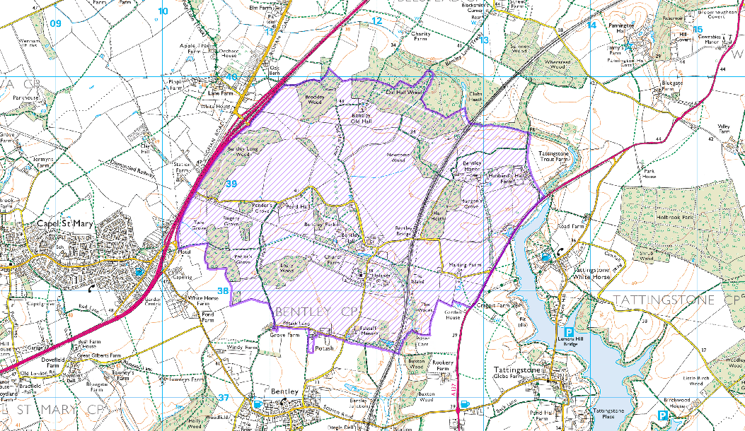

figure 1: The boundary of the newly ‘Designated’ Bentley Conservation Area

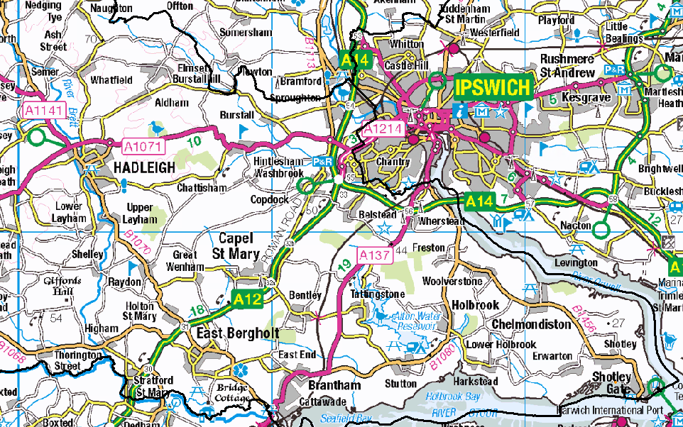

figure 2: The location of the Bentley Conservation Area in its wider geographic context

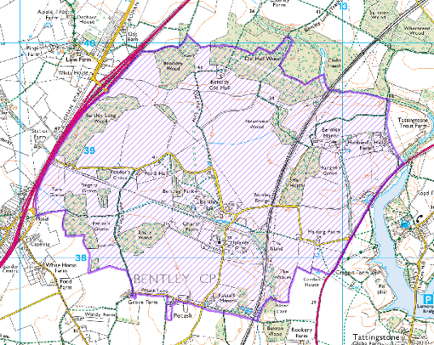
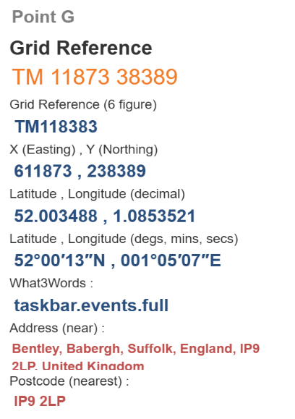
BENTLEY HALL

https://gridreferencefinder.com
figure 3: Co-ordinates (using Bentley Hall shown as the target location)

Also included with this Notification - as attachments accompanying the associated email. are the following documents:

- The record of decision to ‘Designate’ the said Bentley Conservation Area (S69(1)(b) & S69(2) PLBCAA)

- The officers report and appendices setting out the case for ‘Designating’ the said Bentley Conservation Area (Section 69(1)(a) PLBCAA)

Babergh District Council, as local planning authority, has determined which parts of its area are of special architectural or historic interest the character or appearance of which it is desirable to preserve or enhance, and finds that the Area known as the Bentley Conservation Area is one such Area.

The Council is

- placing a Notice in the London Gazette S70(8) for publication on the 16th May 2025
- placing a Notice in a local newspaper S70(8) for publication on the 17th May 2025

- the ‘Designation’ of the Bentley Conservation Area has been recorded as a local land charge S69(4)

I trust that this letter, associated email and attached documents provide you with sufficient information to satisfy the procedural requirement for Notification under S70(5) of the PLBAA.

All relevant documents are published on our website - https://www.babergh.gov.uk/conservation-area-consultations

I politely request written confirmation of this point if it is the case or your kind direction as to what else is required.

Should you have any queries or require any further information please do not hesitate to contact me.

Kind regards

Vincent Pearce,
Principal Planning Officer,
Planning Service,
Babergh Mid Suffolk District Councils
Endeavour House
8 Russell Road
Ipswich
Suffolk
IP1 2BX

vincent.pearce@baberghmidsuffolk.gov.uk
01449 724523

